谭树杰 11849060

Lab5 Report

The main() function of this project is shown below:



1. Filter lena.pgm and bridge.pgm using IDLPF, BLPF, GLPF and compare the image qualities with different cutoff frequencies
2. filter lena.pgm and bridge.pgm using IDLPF

The lena.pgm and processed images using D0 = 30, 60, 160, 460 are shown below:

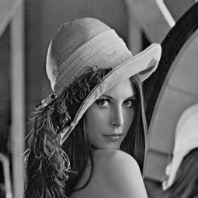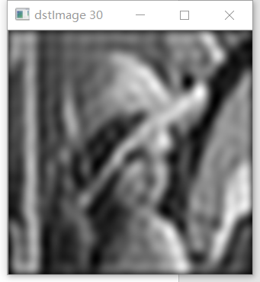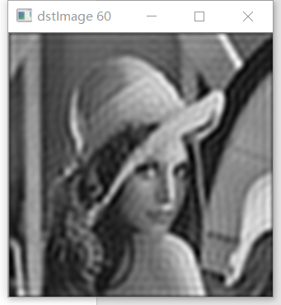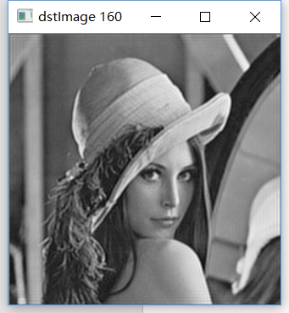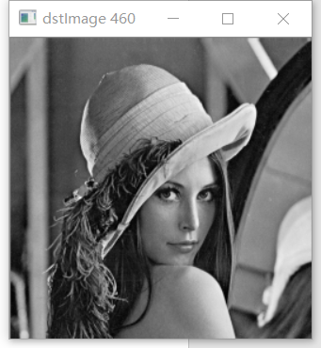

The bridge.pgm and processed images using D0 = 30, 60, 160, 460 are shown below:

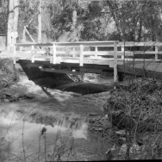 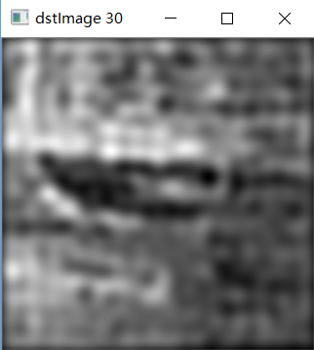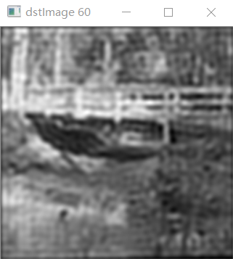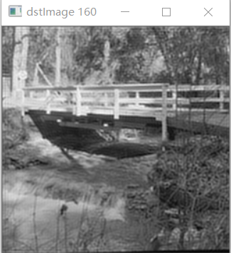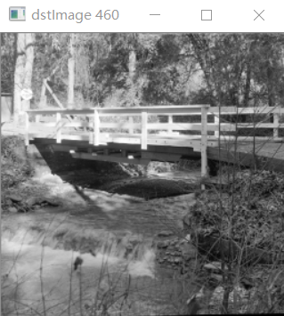

Analysis: From the images above, we can see the blurring and ringing through the increment of cutoff frequency D0. When D0 = 30, we can hardly recognize the objects in the image, for that we only reserve small low frequencies of the images. As D0 increasing, the images become more and more clear and the ringing reduces. Because more and more high frequency information is reserved.

The IDLPF is implemented in the following code:



1. filter lena.pgm and bridge.pgm using BLPF

The lena.pgm and processed images using N = 2 and D0 = 30, 60, 160, 460 are shown below:

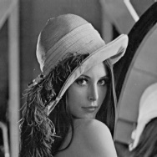 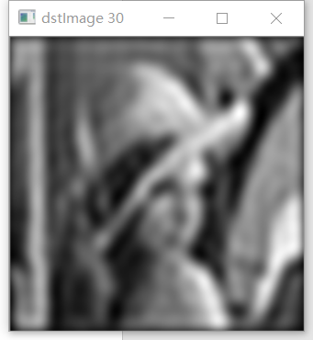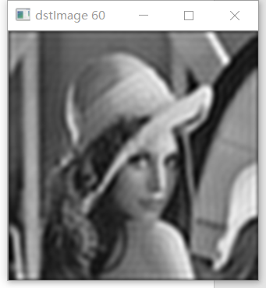 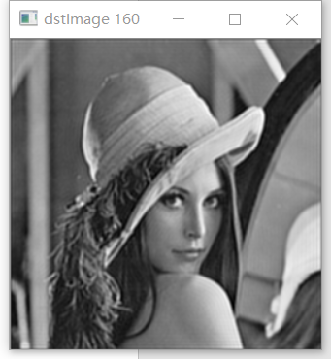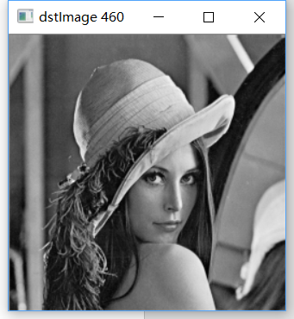

The bridge.pgm and processed images using N = 2 and D0 = 30, 60, 160, 460 are shown below:

****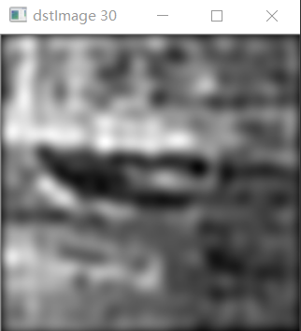 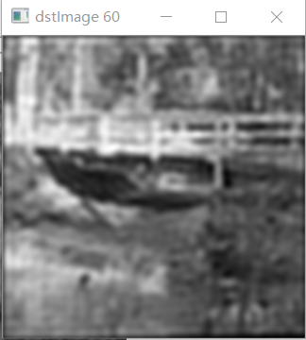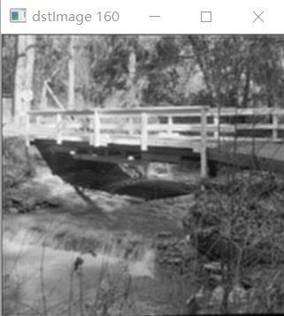 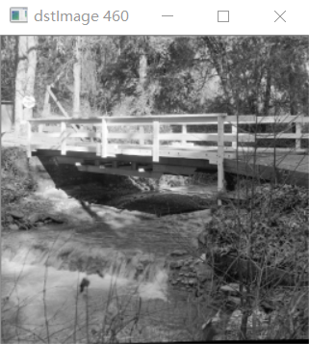

**Analysis: Not as IDLPF, the ringing is not visible in any images above. Because BLPF is of smooth transition between low and high frequencies. But ringing can become significant in hihg order BLPF.**

The BLPF is implemented in the following code:



1. filter lena.pgm and bridge.pgm using GLPF

The lena.pgm and processed images using D0 = 30, 60, 160, 460 are shown below:

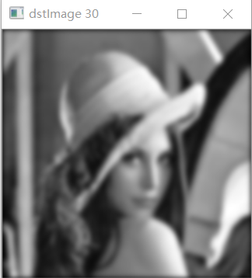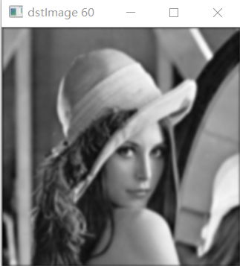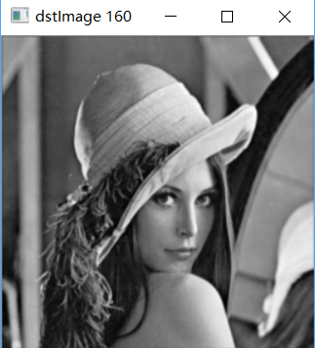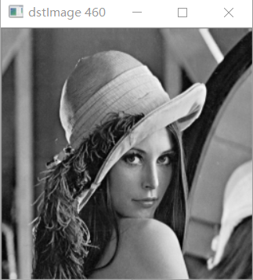

The bridge.pgm and processed images using D0 = 30, 60, 160, 460 are shown below:

****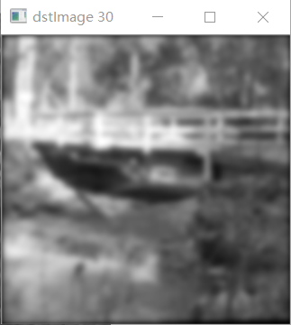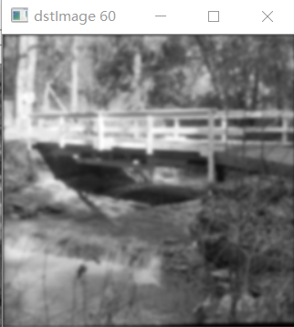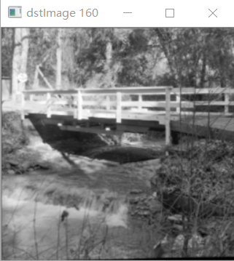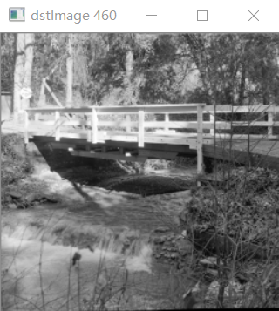

**Analysis: We observe a smooth transition when cutoff frequency is increasing. The ringing is more invisible in any images above. Because the profile of GLPF is not as tight as the profile of the BLPF of order 2.**

The GLPF is implemented in the following code:



1. Use HPF and thresholding to sharpen fingerprint1.pgm and

fingerprint2.pgm

**The fingerprint1.pgm and its image after BHPF and thresholding are shown below**

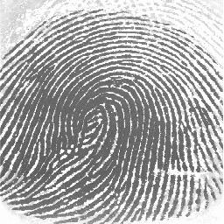 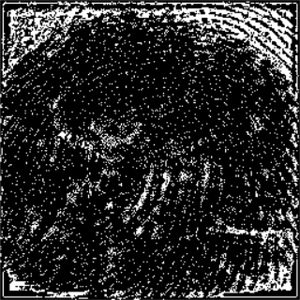 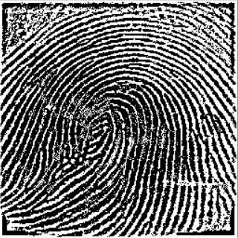

**The fingerprint2.pgm and its image after BHPF and thresholding are shown below**

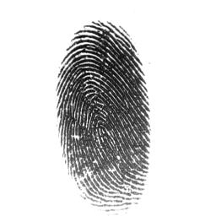 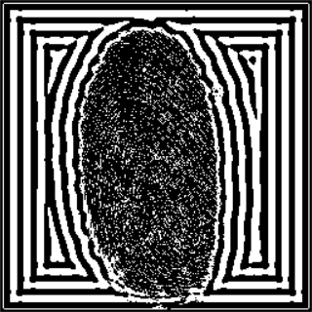 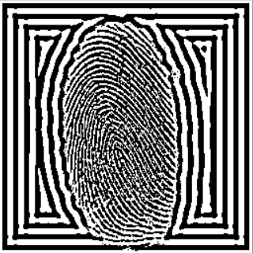

**Analysis: We can see the enhancement of print ridges and the reduction of smudges in fingerprint1.pgm and fingerprint2.pgm clearly. The highpass filter won’t change the high frequencies contained in the ridges. In contrast, the filter reduces low frequency components corresponding to the smudges and background. That’s why we achieved the effects above.**

The GHPF and thresholding is implemented in the following code:

